CNC Sewer
- Maintainer: yomin
- Date: 2013-11-03
- Status: ongoing
The CNC Sewer will combine a sewing machine with our cnc milling machine. The result will be a sticking like operation.

ToDo

Concept
- sewing machine fix, embroidery frame moves
- limited to ~15cm diameter embroideries
- sync of cnc and sewing machine
  - hand wheel triggered limit switch
  - mach3 knows whether needle down or up
  - conditional gcode waiting for needle up
- creating gcode
  - knitting machine software with Melco exp format (eg. embroider for inkscape)
  - own tool exp2gco, converts exp code, adds conditional limit switch code

Progress
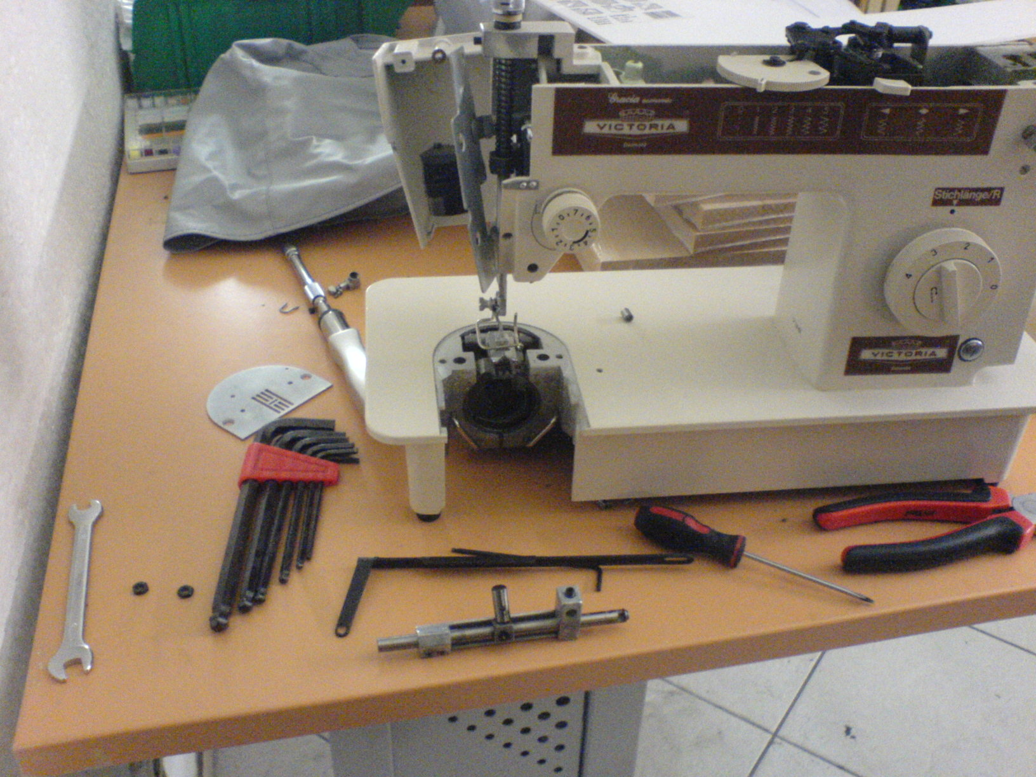sewing machine repair
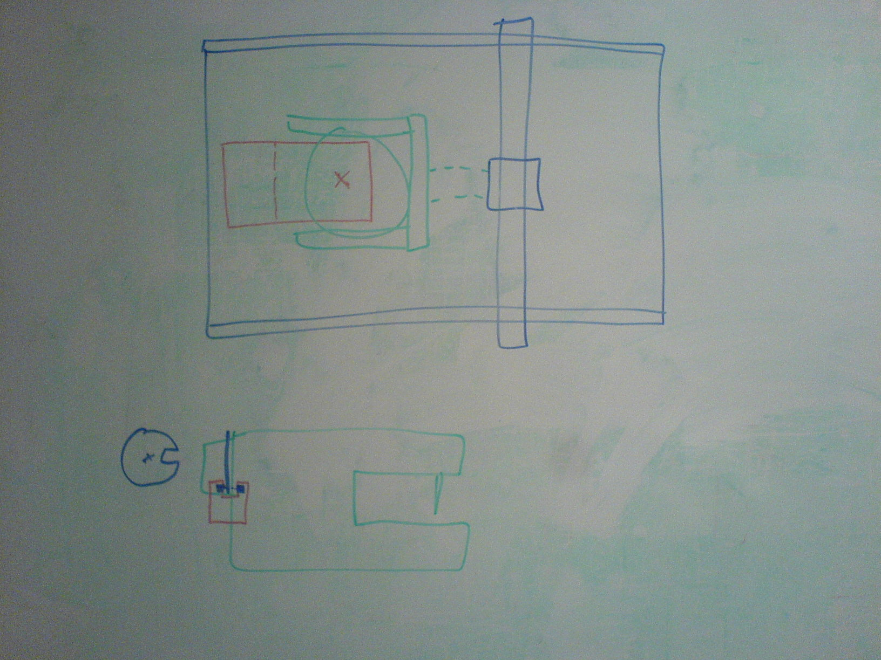concept
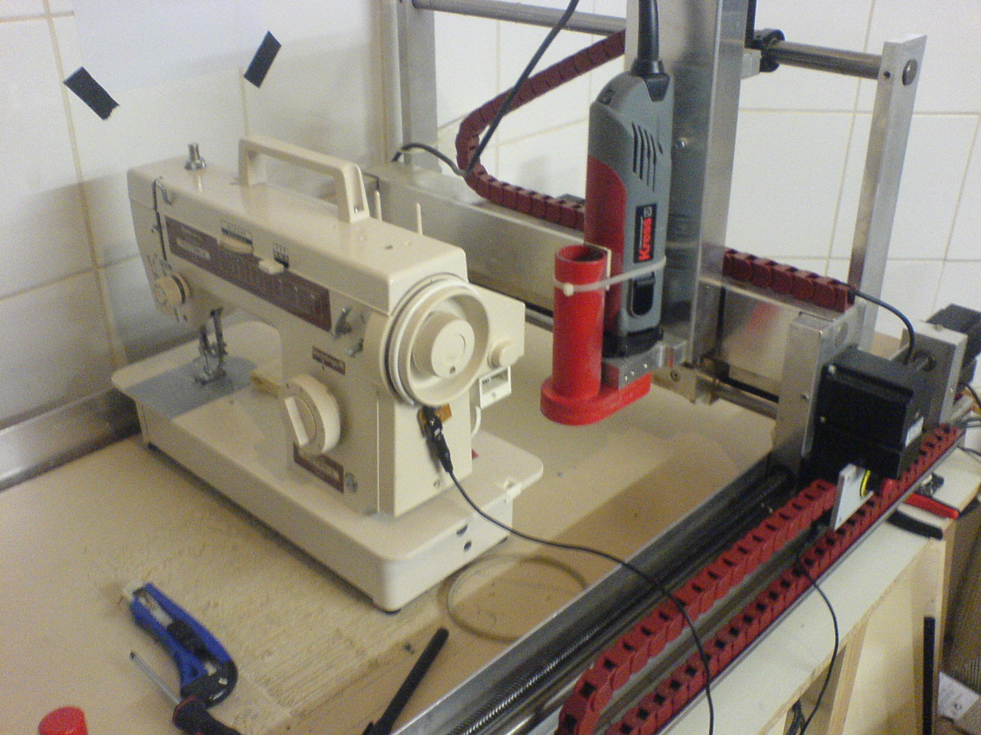sewing machine to cnc machine
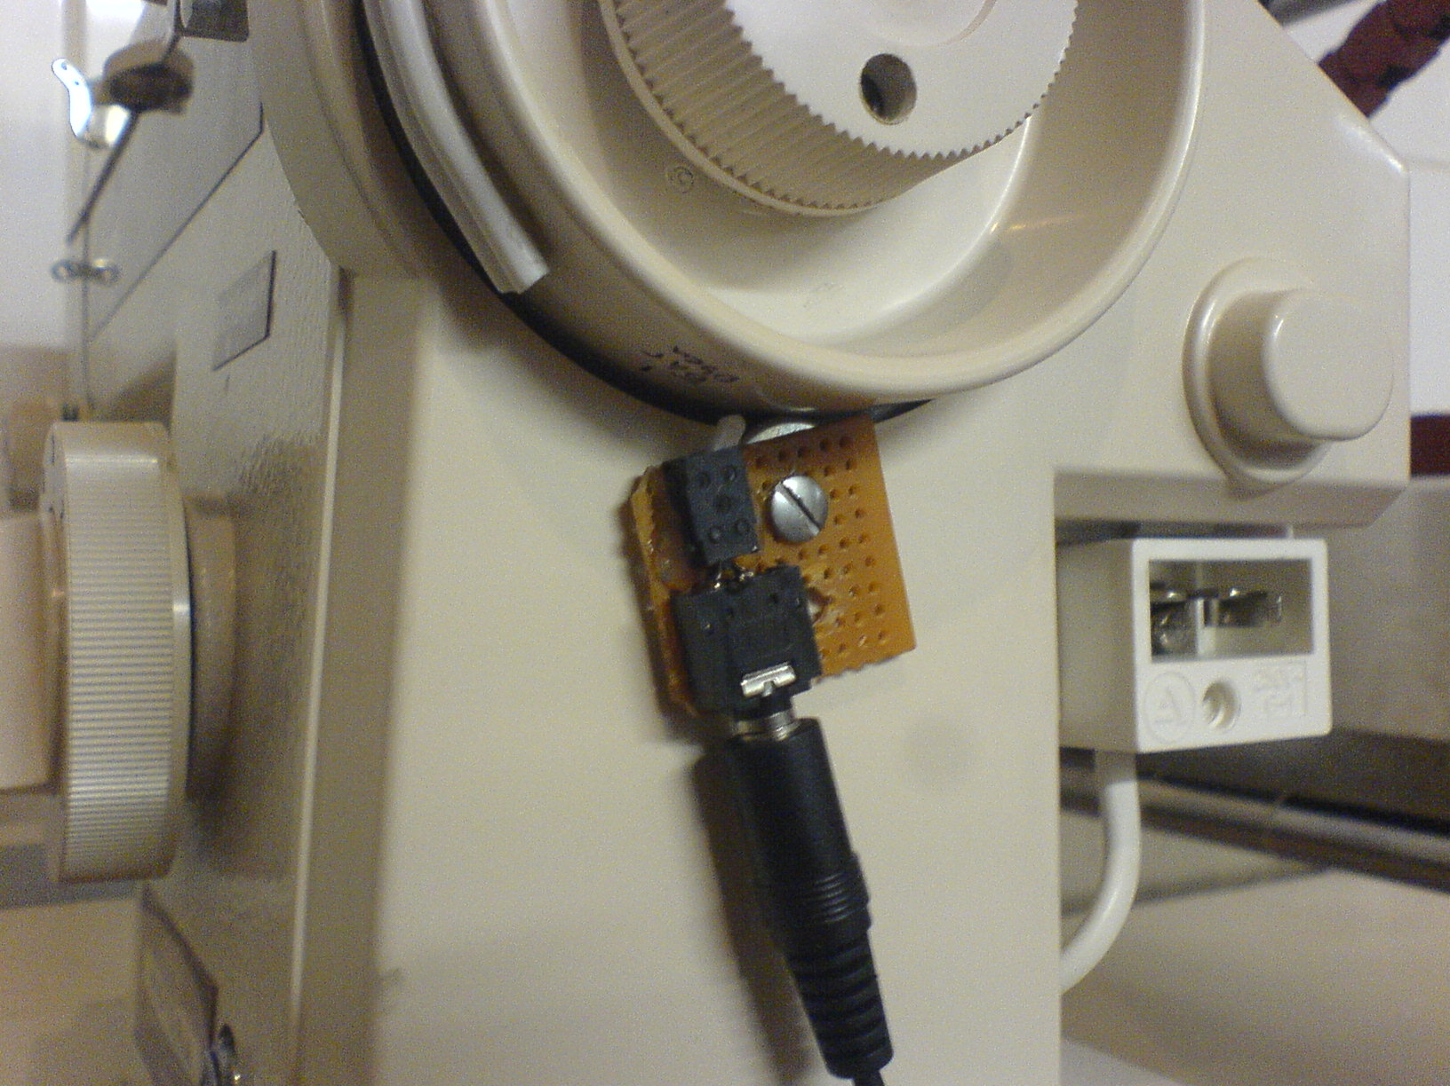hand wheel triggered limit switch
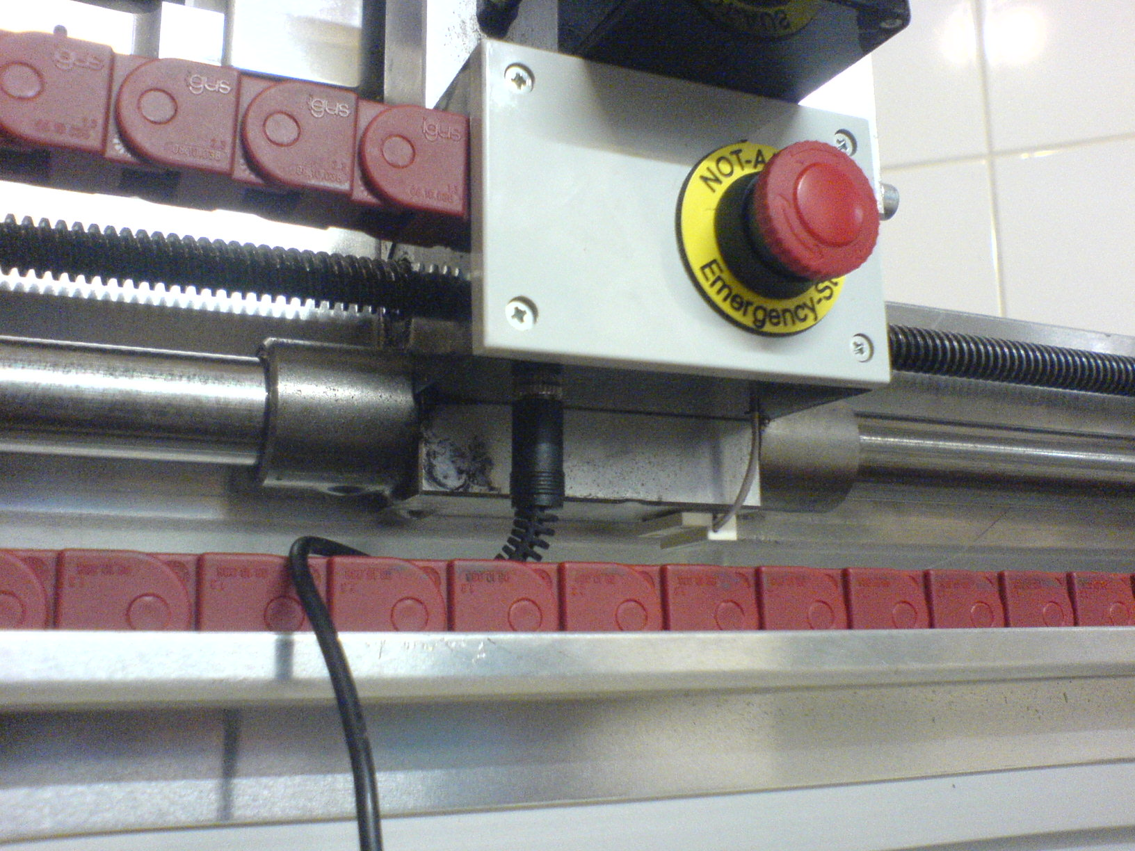secret limit switch input
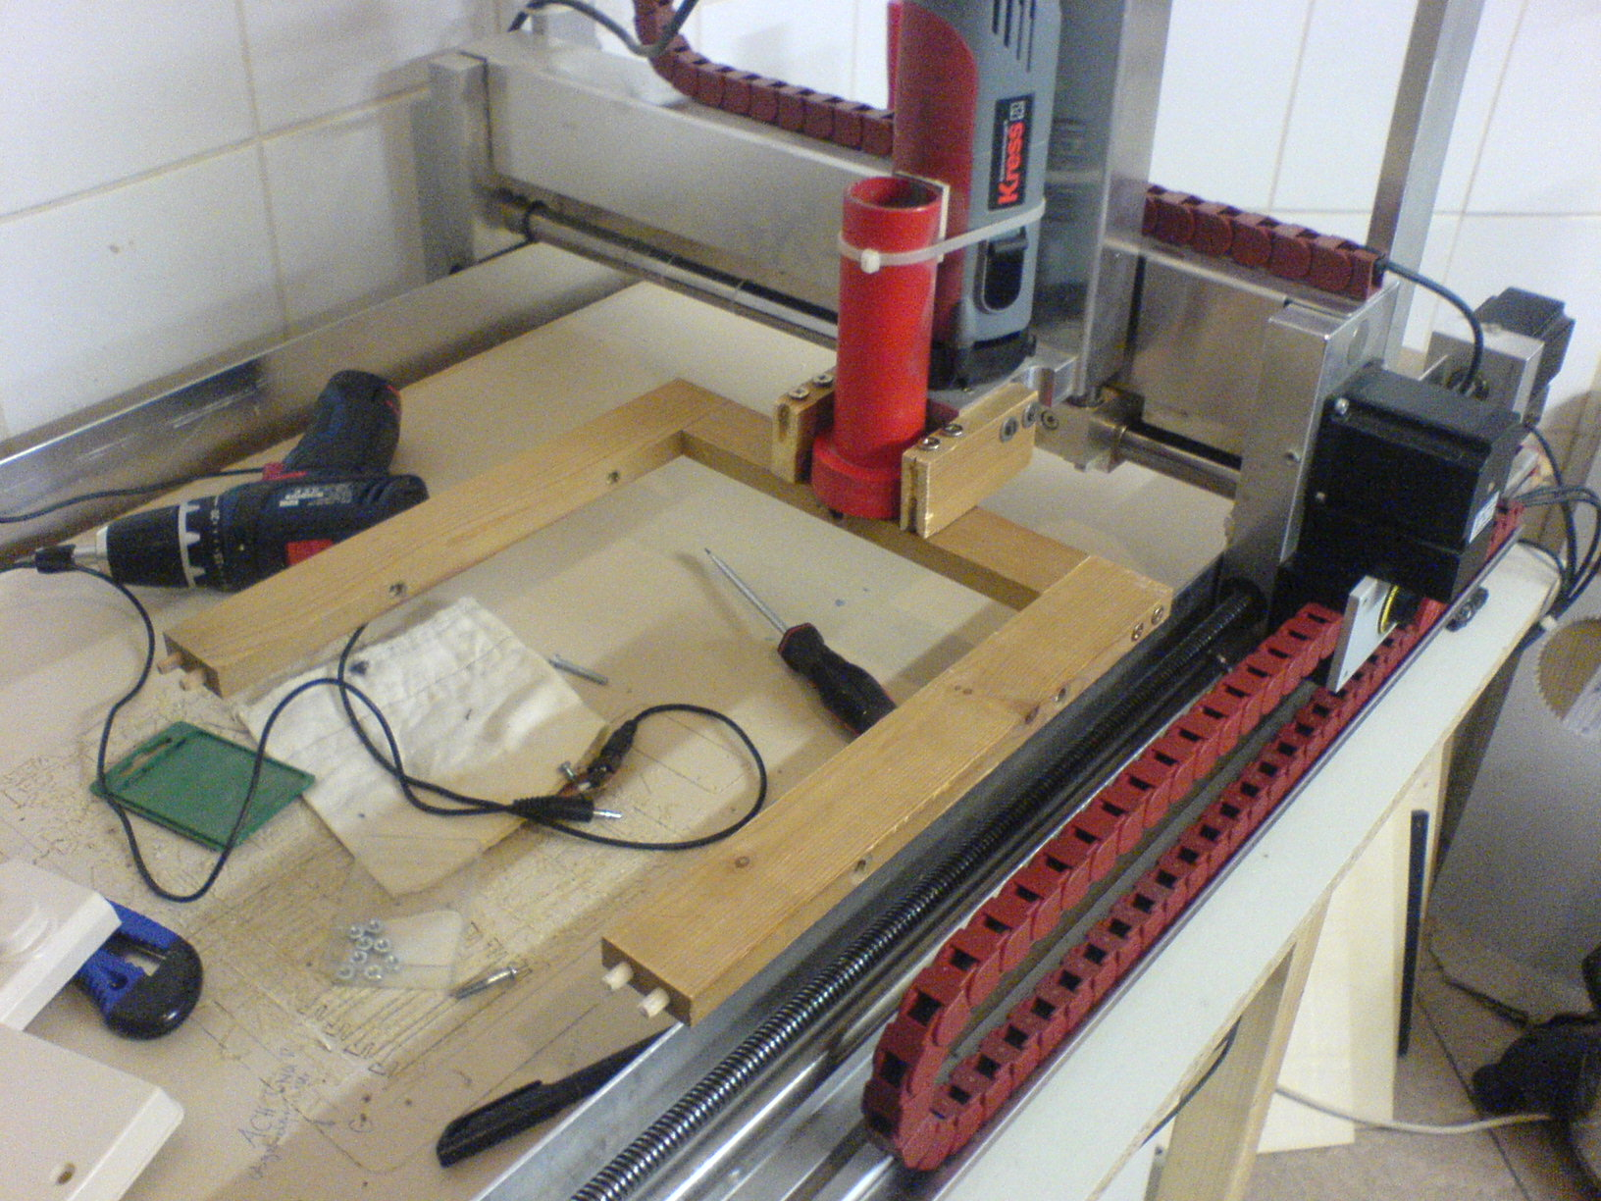embroidery frame mounting
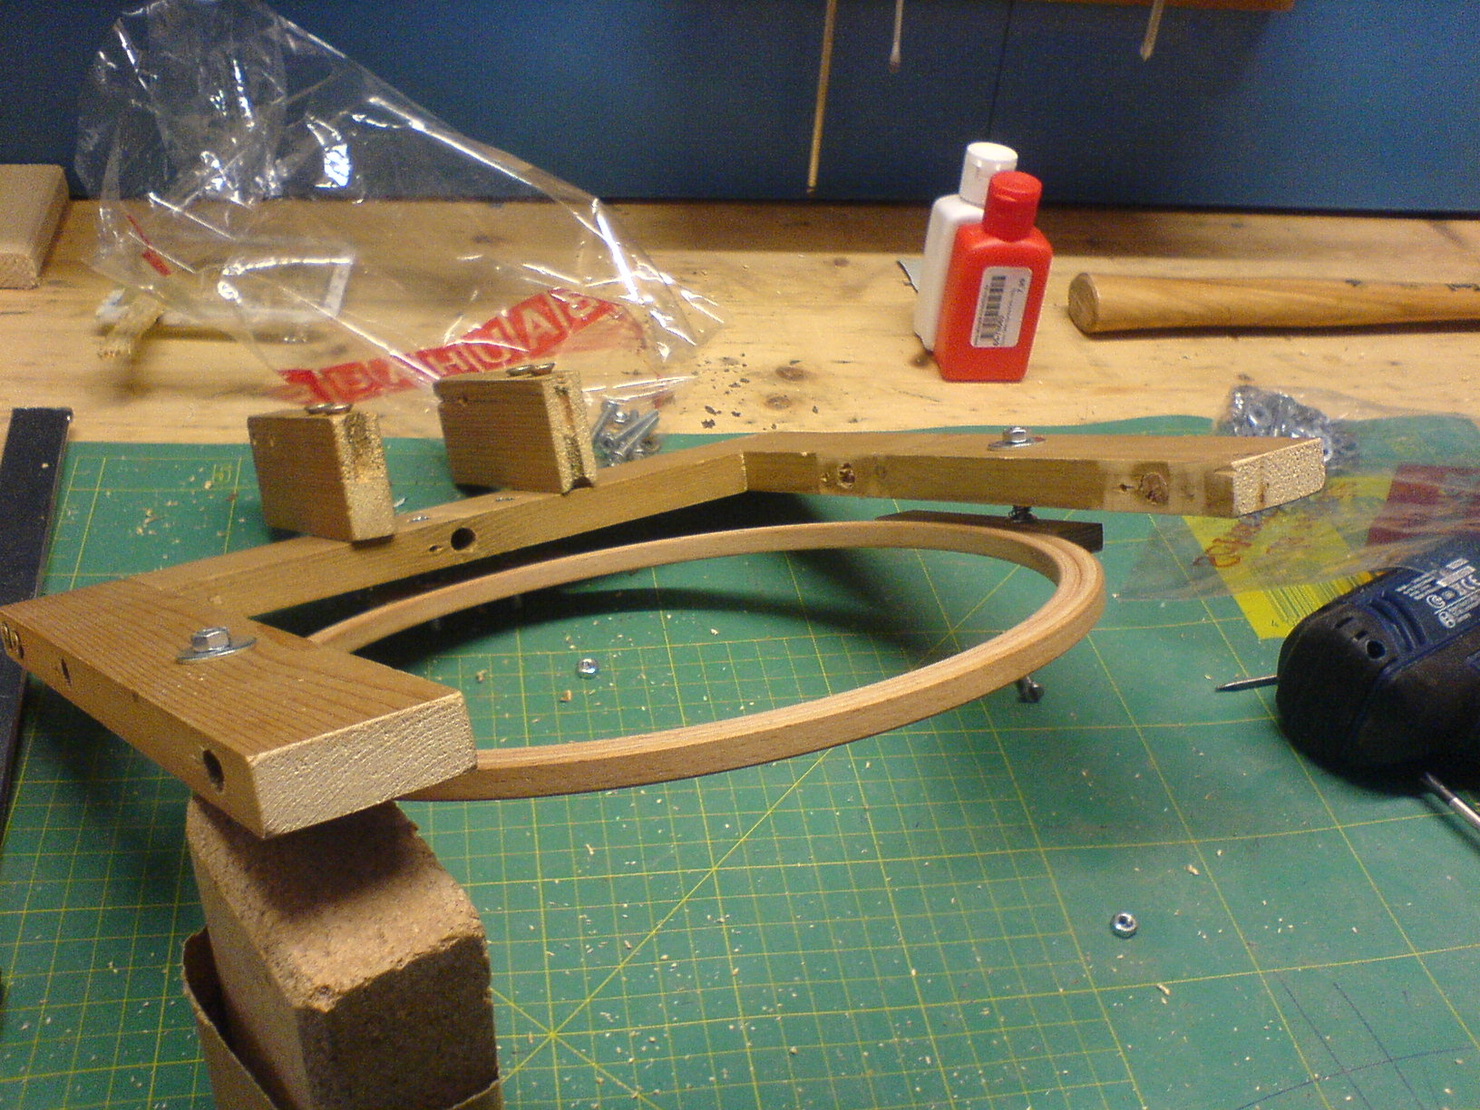mounting with installed embroidery frame

Links
- http://hackaday.com/2014/06/10/diy-embroidery-machine-sews-your-name-in-your-undies/

