Lockpicking
- Picker: yomin
- Resources: box with locks, keys, hooks and wrenchs for training at the space
Lockpicking, the art of opening locks without damage, is also utilized by people of the Netz39 Hackerspace. If you want an introduction or tips and howtos just ask. For beginners the lockbox contains one special ABUS Buffo lock wich is onesided opencut to reveal the mechanism.

Sternbrücke LoveLockBreak
Because locks are expensive and the lockbox ones boring after some time new locks can be found at multiple locations in Magdeburg. The next to the space location is the Sternbrücke providing lots of love locks. Pasttime lockpicking resulted in a long chain. Next year new ideas are needed for interesting new combinations of the picked love locks.
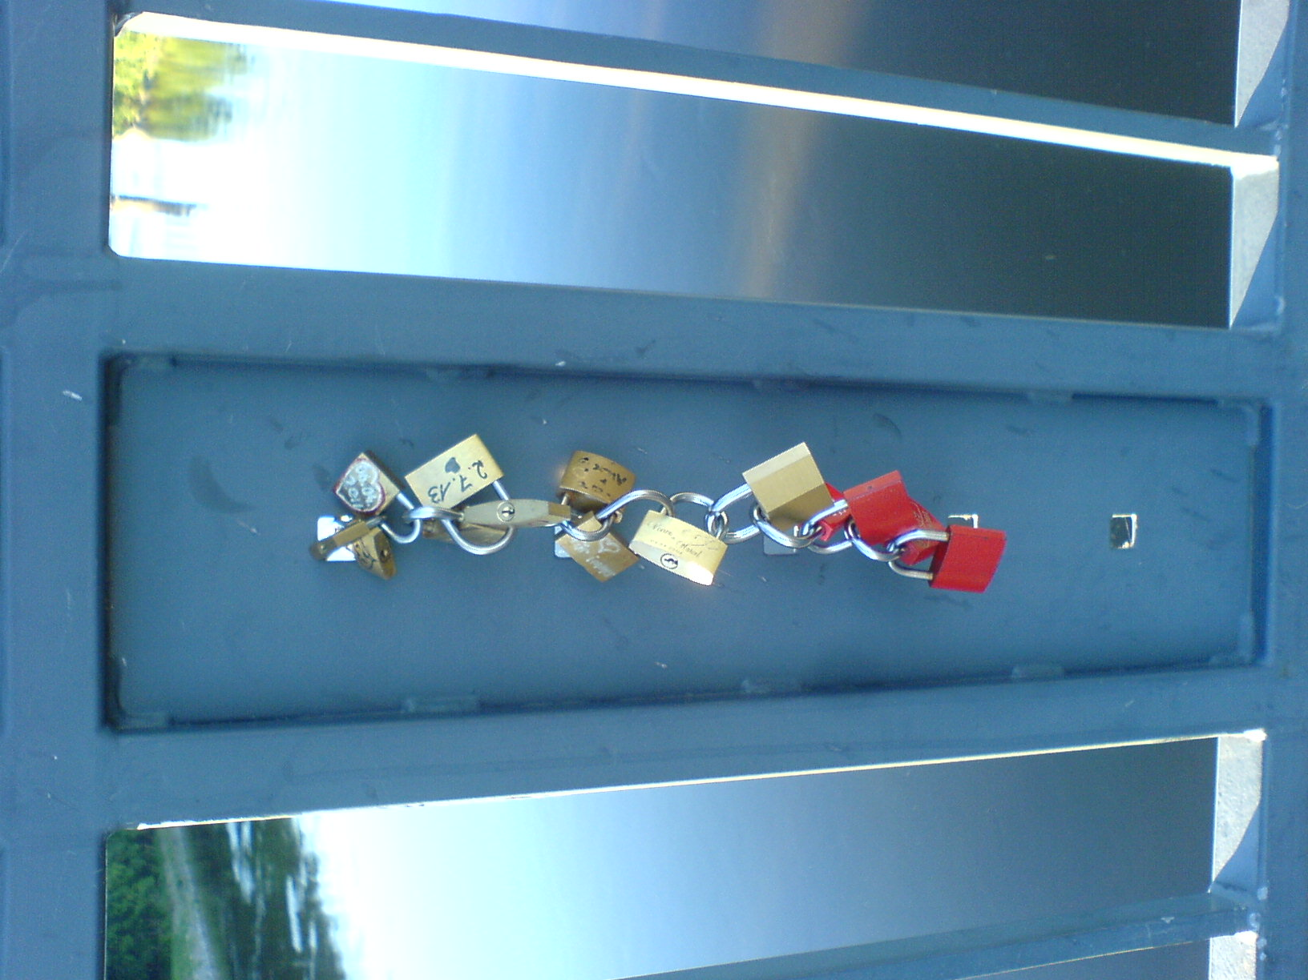Day 1: lets make a chain
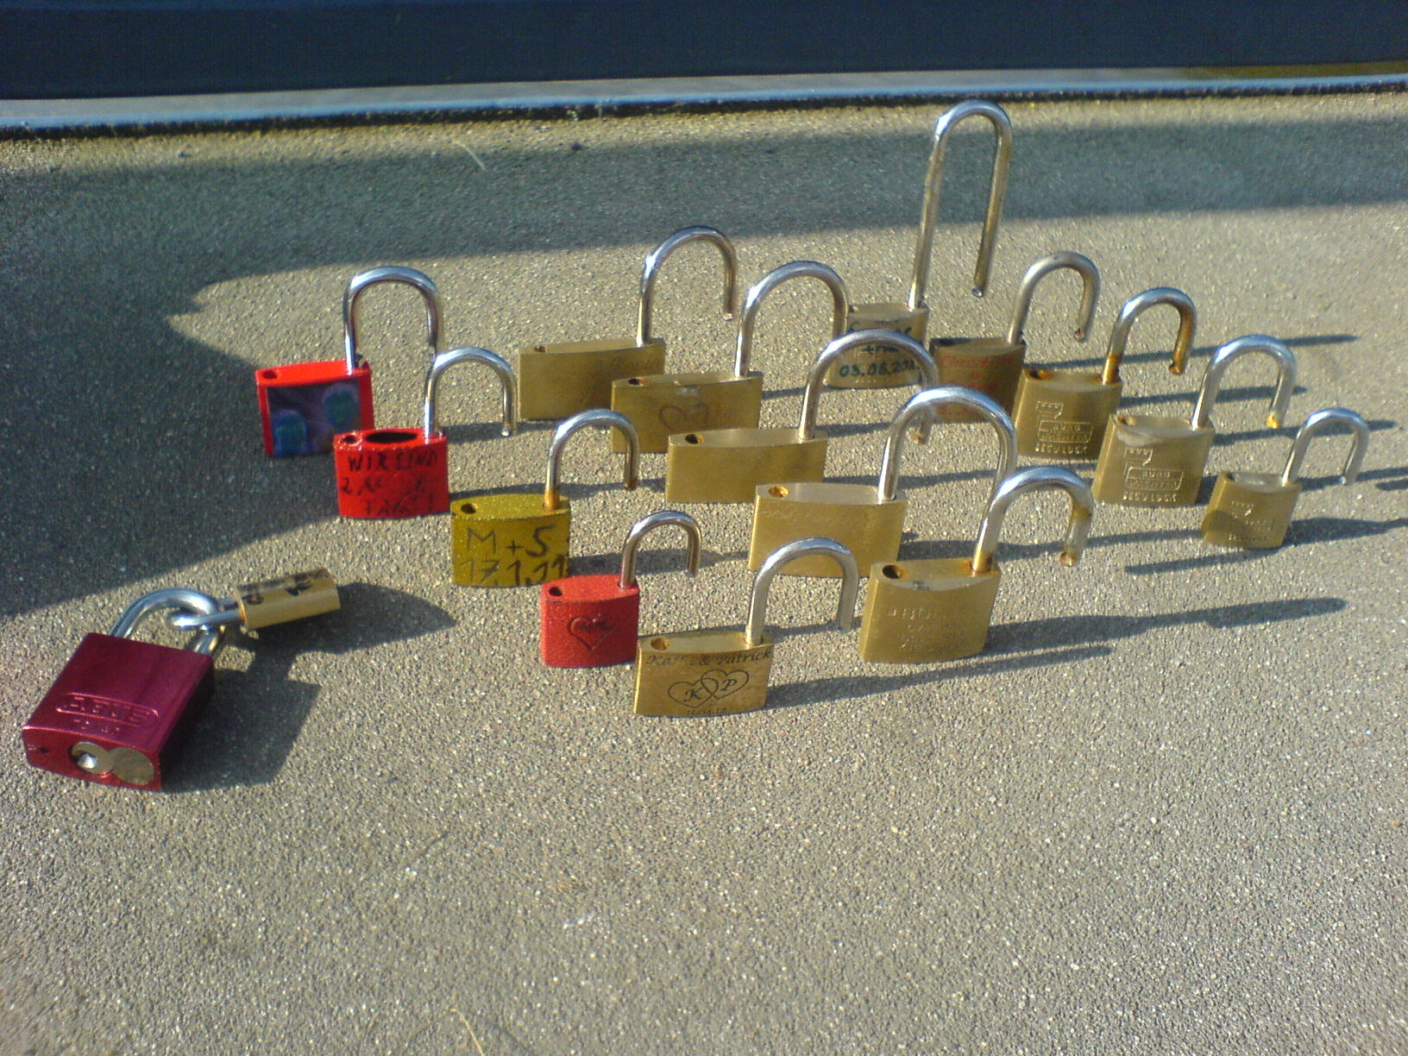Day 2: haul
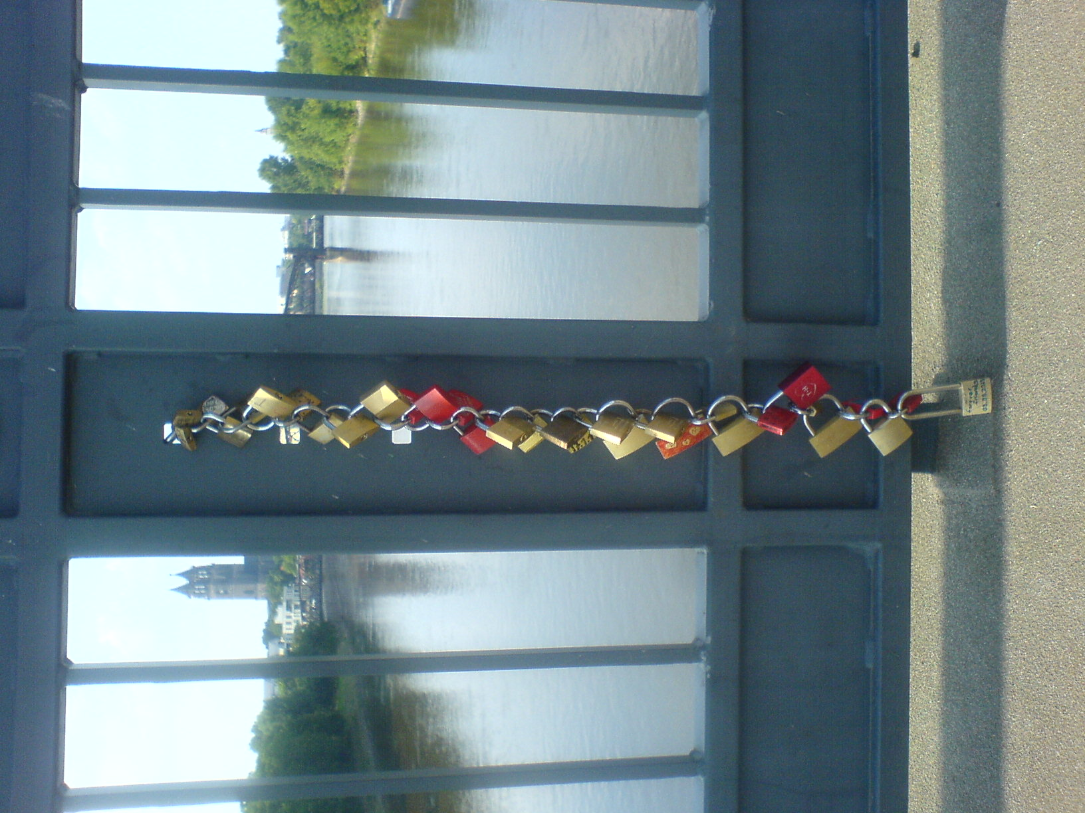Day 2: the chain surely isnt long enough

