LAN TAP Throwing Star
- Maintainer
yomin
- Date
2013-03-25
- Status
finished
- Resources
https://github.com/Yomin/throwing_star
- Cost
~2.50 Euro
Board for Michael Ossmanns famous Throwing Star. http://greatscottgadgets.com/throwingstar
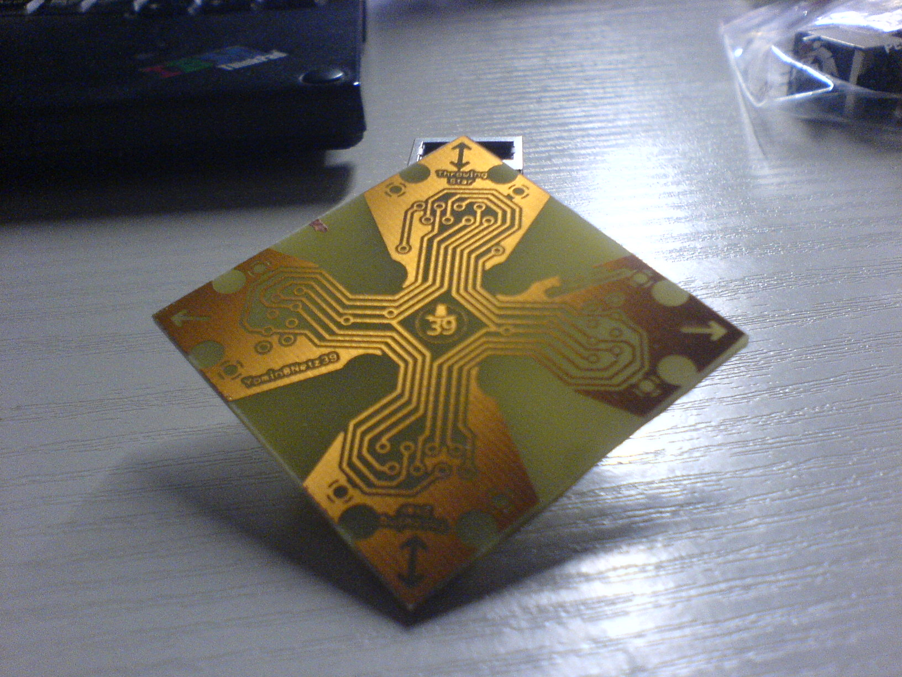etching done
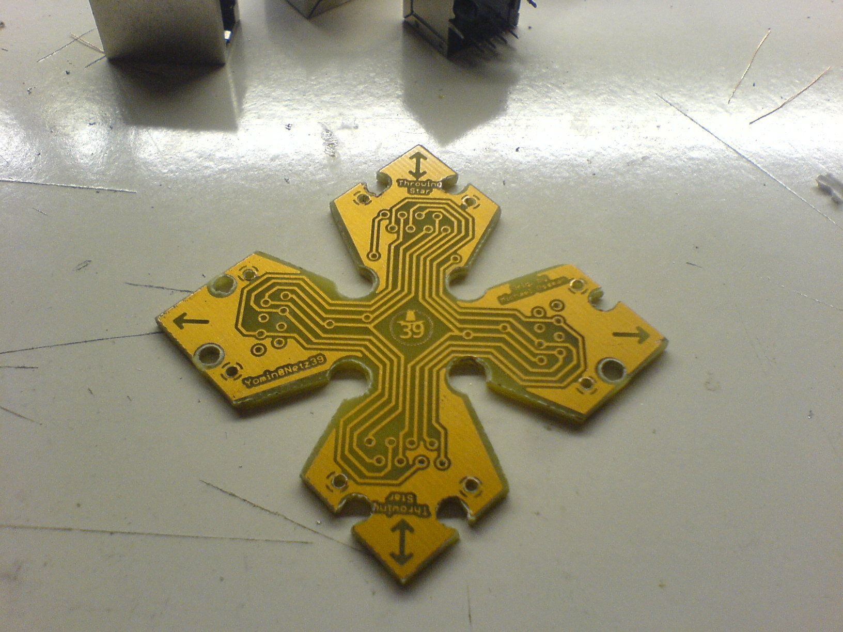drilling 'n' milling done
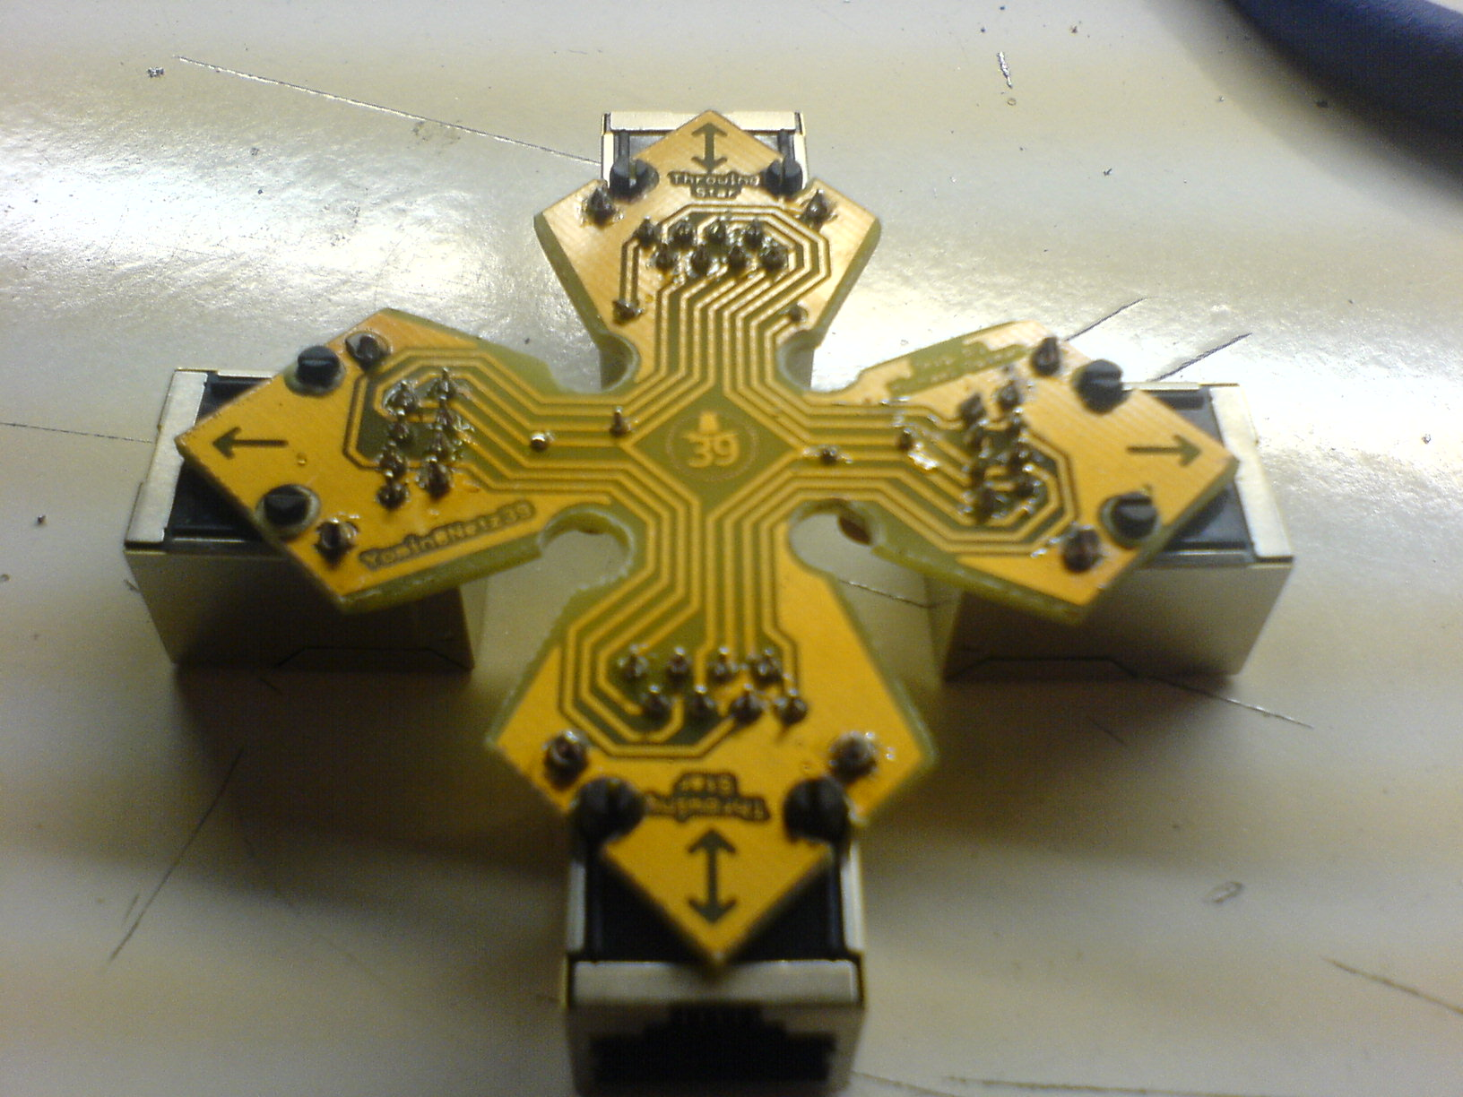soldering done bottom
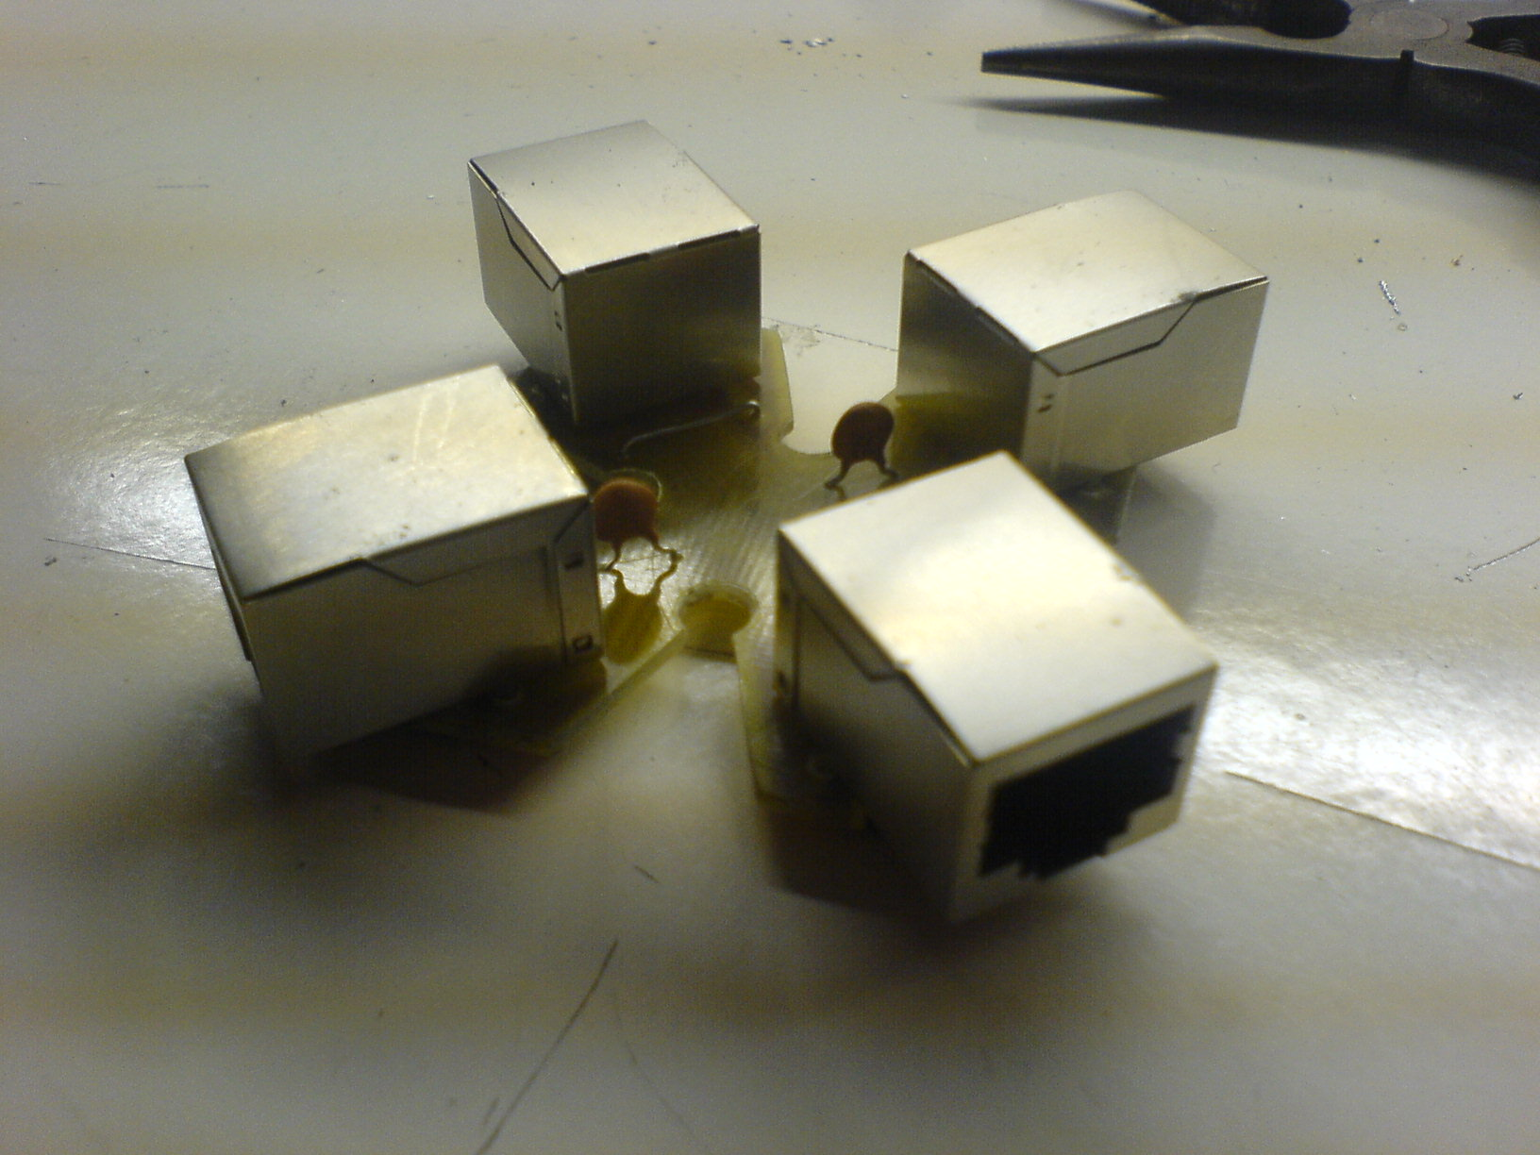soldering done top
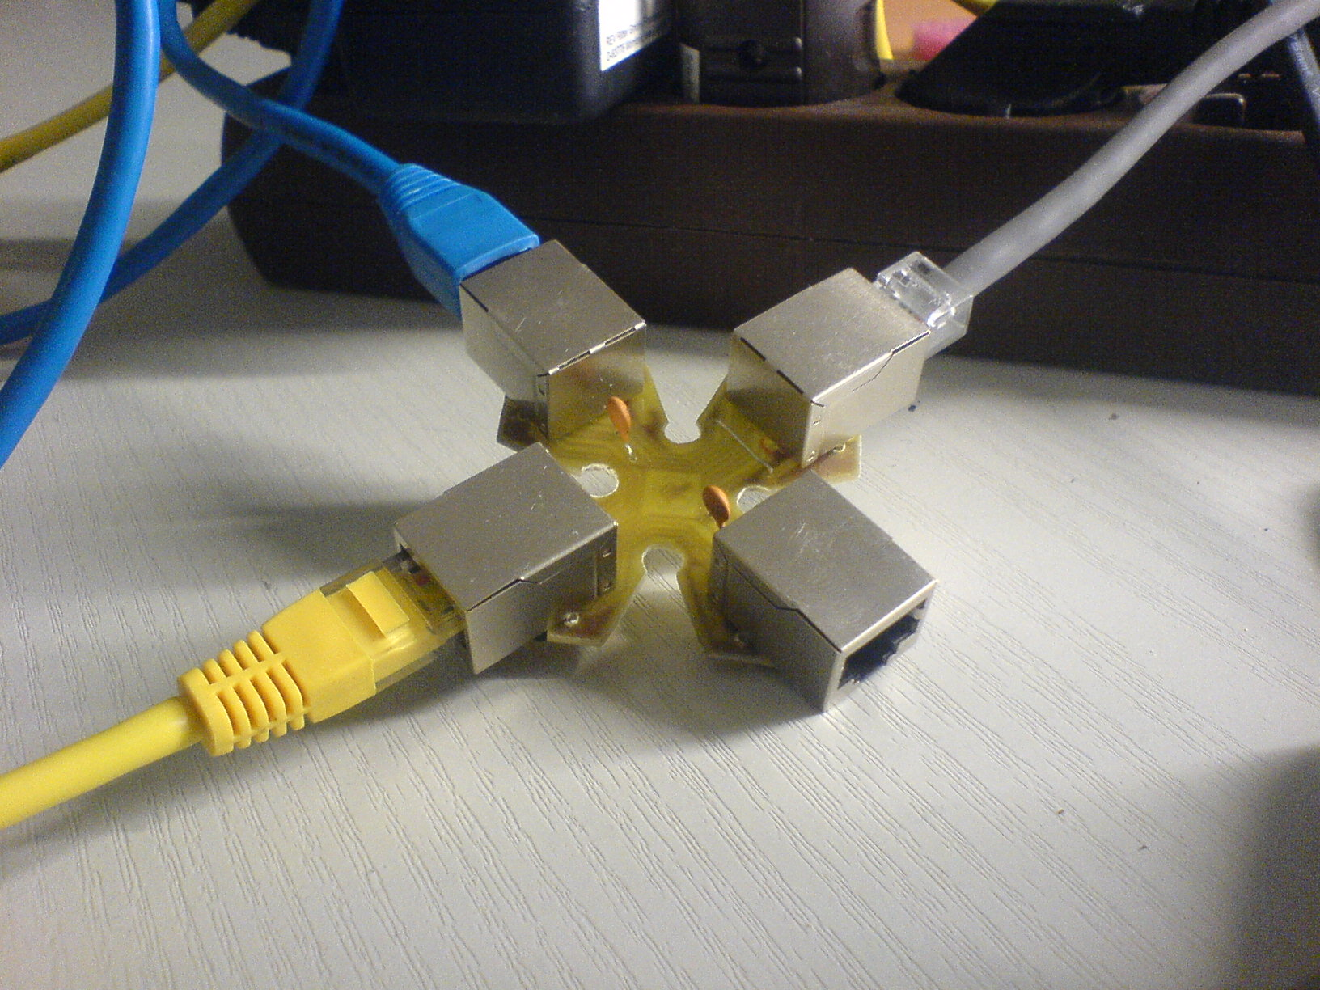sniffing done

