Johannes Filter
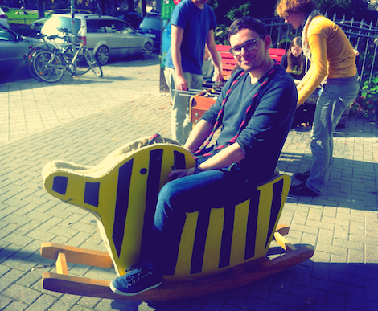

Contact
- E-Mail
hi@jfilter.de
- Twitter
@fil_ter
- Jabber/XMPP
filter@jabber.n39.eu

Interests
- Politics
- Web
- Podcasting
- Freifunk
- Journalism

