Martin Rödel

Nicks
- Yomin
- The Keymaker
- Klettermartin
- Hutmartin

Projects
- Relais Computer
- CNC Sewer
- Kimono
- Lockpicking

Finished Projects
- reverse engineering the OVGU student card
- FTDI Breakout Board
- LAN Tap Throwing Star
- Japanese Garments
  - Haori
- LED Display
- Bulbdial Clock
- Blinkedings Ultimate
- klocam

Future Projects
- nightvision
- something with my acoustic coupler (cool idea missing)
- something with my old vending machine smart card reader (first reverse engineering needed)
- DECT phones + asterisk = profit?

Personal Projects
- Art Teco - ncurses based text editor
- Neobox - OpenMoko Neo userland replacement
- dmenu with filecompletion
- space status trayicon
- Tabakdosendeckelgravur

Skills
- Linux common knowledge (Fedora laptop, Arch server, Debian phone)
- C, Haskell, Erlang, bash
- AVR
- Eagle
- microwave pizza
- basic Klingon (Klingon Boggle partner wanted!!), basic Japanese
- Climbing, Bouldering
- basic reverse engineering
- soldering (SMD in progress)
- GIT
- etching
- basic lockpicking
- rubics cube in various forms and types
- sewing

Possessions
- PKW
- Openmoko Neo Freerunner
- IDTronic EVO LF (125KHz RFID Reader)
- SCM SCL3710 (NFC Reader)
- Newsky TV28T DVB-T SDR
- 60m rope, boulderpad, 4 friends, 5 nuts, lot of slings

Hardware For Projects
- 1 acoustic coupler
- 2 thin clients (Itona TC4533/TC6933)
- 7 Linksys WRT54G(S)
- 1 Epson LQ-400 matrix printer
- 4 Siemens Optipoint 500 Standard
- 10 DECT phones (Siemens, Panasonic, Philips, T-Easy)

Interests
- networking stuff
- microcontroller stuff
- functional programming stuff
- *nix stuff
- Randian Objectionism
- Japanese
- Zen Buddhism

Favorite Lectures
- Operating Systems
- Kommunikation und Netze
- Functional Programming
- Mainframe Computing

Favorite Games
- Minesweeper (1:47 prof beat me)
- Deadspace
- Bioshock
- CS (lets play glasfun)
- NES Snake Rattle 'n' Roll

Favorite TV Series
- Stargate
- South Park

PGP Fingerprint
049C F0AC 6457 A7F3 6DC9 C760 5B8C EBB8 1C58 177B

Pics
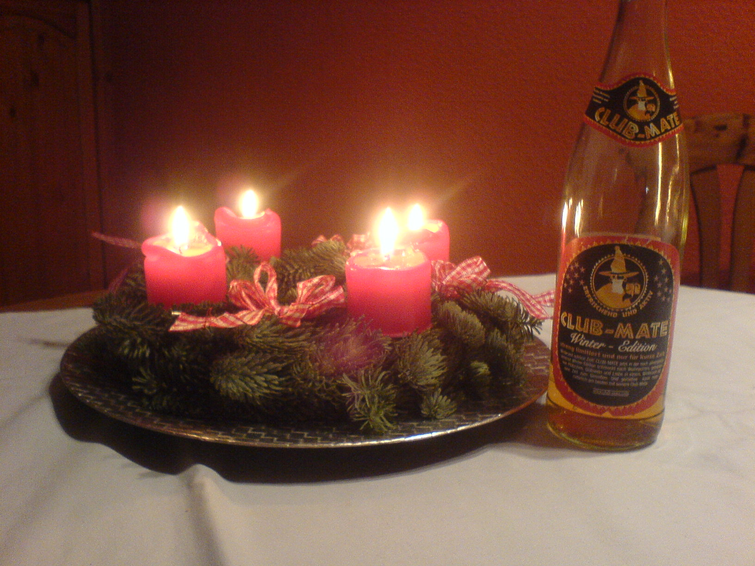gemütlich!
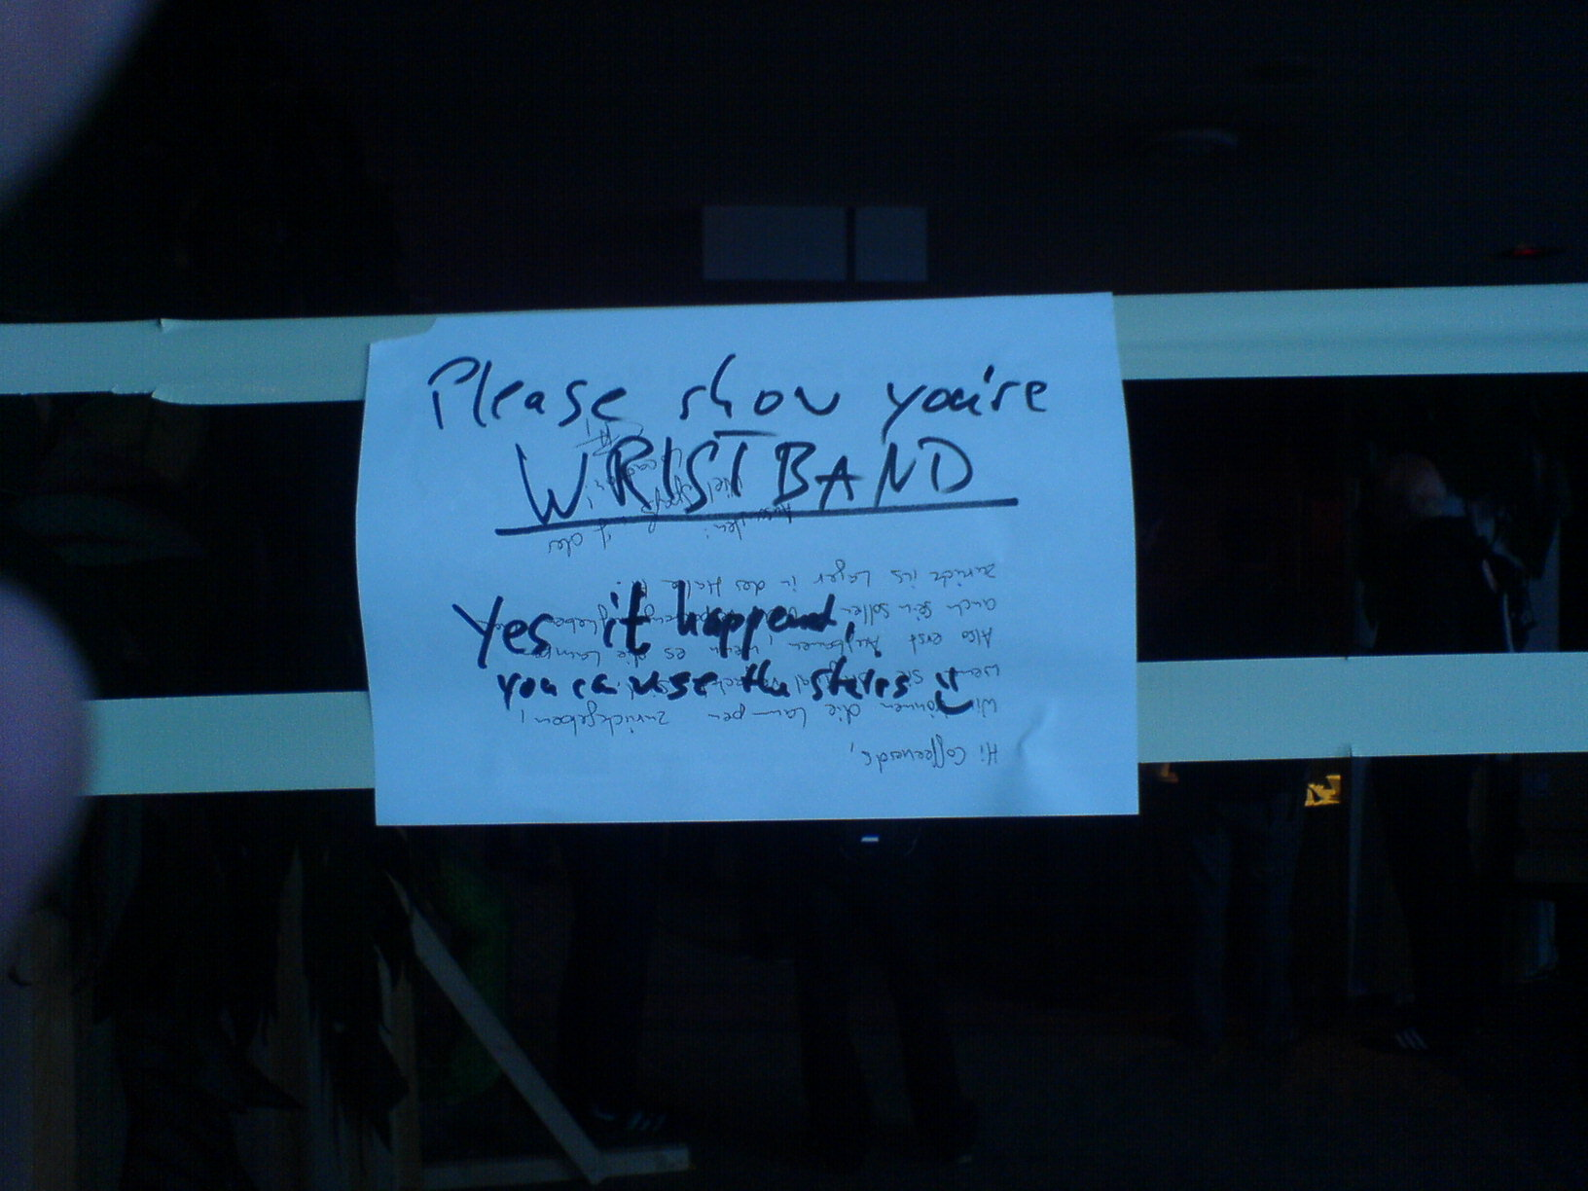Beeing angel at 30c3 4th floor smokers entrance everyone but a few didn't bother to show their wristband/stamp and thereafter asked why its necessary to show it. So we hung a message at face height into the door even provoking grammar nazis. But guess what. Only half the people even bothered to read :/ Spot the grammar nazi honeytrap ;)

